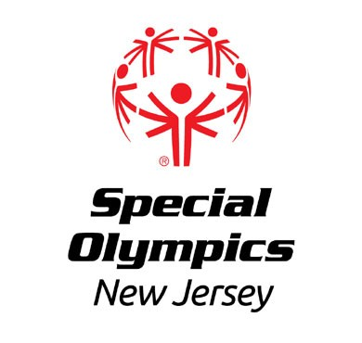

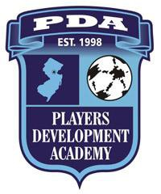

PDA Soccer Marathon 2020
To benefit

SPECIAL OLYMPICS NEW JERSEY
Jan 24th – 25th

3:00pm to 3:00pm
The Players Development Academy will host a 24-hour soccer marathon as a charity/fundraising event. Players from the PDA soccer club teams will participate in the marathon to support the PDA and Special Olympics New Jersey. Special Olympics New Jersey and the Players Development Academy are 501(c)3 non-profit organizations. 50% of the net proceeds will benefit Special Olympics 50% will benefit the PDA's scholarship fund and the Capital improvement fund.
Special Olympics New Jersey is a statewide sports and athletic competition program which provides year-round opportunities to children and adults with intellectual disabilities to participate in sports. Children as young as 8 years old are eligible to participate in many events held throughout the year. Special Olympics competitions are patterned after the Olympic Games. Over 15,000 competitions in both summer and winter sports are held each year in communities worldwide. Events are conducted on the local, area (county), chapter (state), and international levels. More than TWO MILLION athletes participate worldwide.

Special Olympics New Jersey is widely recognized for the strength of its program and constantly strives to recruit more athletes and develop higher quality programs of training and competition.
For more information go to the Special Olympics New Jersey website: http://www.sonj.org
The Players Development Academy (PDA) is committed to developing youth soccer. The PDA seeks to offer a challenging, competitive, and educational program in which athletes will develop their soccer skills and learn sportsmanship, citizenship, and fair play. To this end, the PDA portion of the proceeds from this fundraiser will be used for the continued development of the PDA soccer programs and scholarships.

For more information, visit www.pdasoccer.org
This event provides an opportunity for the PDA players to contribute to their club and to the community, while doing what they do best -- play soccer. We encourage the support of all PDA families.
Please contact Maura McLaughlin at maura.mclaughlin14@gmail.com or 908-812-4848.
----------------------------------------------------------------------------------------------------------------------------- ----------------------
Special Olympics New Jersey I PDA Soccer Marathon
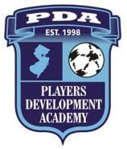
|

Make checks payable to "PDA"
Reference Soccer Marathon and send to: |
Players Development Academy (PDA) 31 Roebling Road Bernardsville, NJ 07924
|

|

Player:
| Special Olympics New Jersey I PDA

Team:
$ per Hour x 24 Hours: $ | Soccer Marathon
Name: | Amt. Donated: $ Address: | Date__________________
Phone: | Check: #

| Cash: $

